**Sec 2 Subject Combination Portal**

**URL : https://huayi.schoolhub.sg**

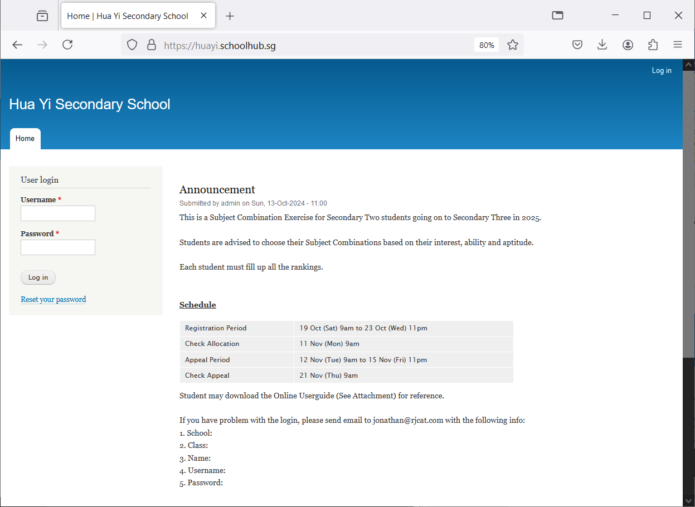

Enter username and password and Click Login

Step

* Enter Username
* Enter Password
* Click LOG IN

## Update Account

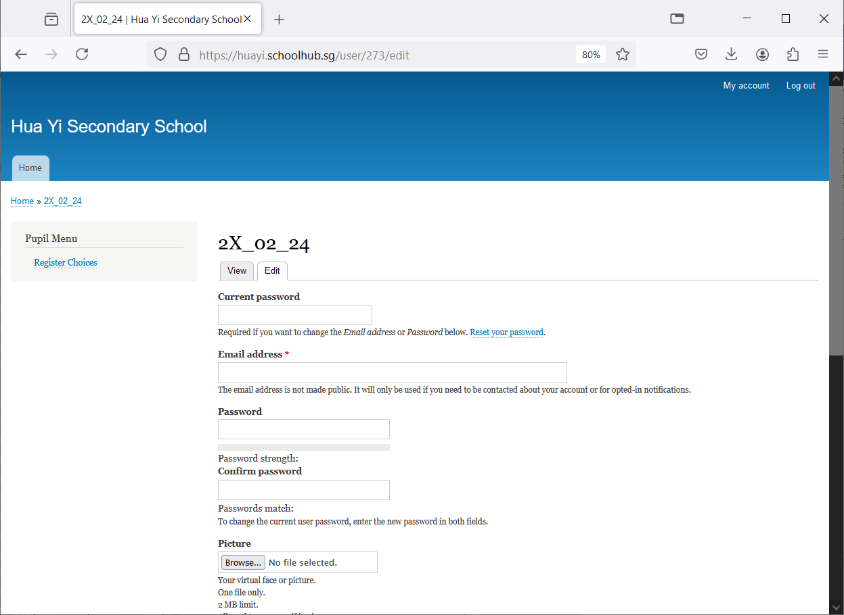

Step

* Enter Current Password
* Enter your eMail Address
* Enter New Password
* Enter Confirm Password
* Click SAVE

## Register Choices

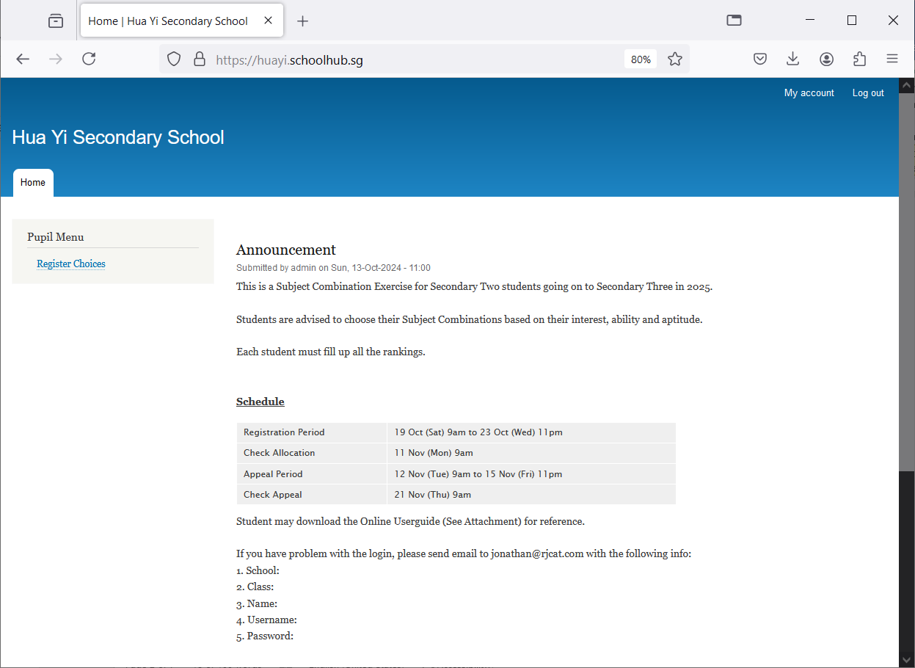

Click Register Choices to begin

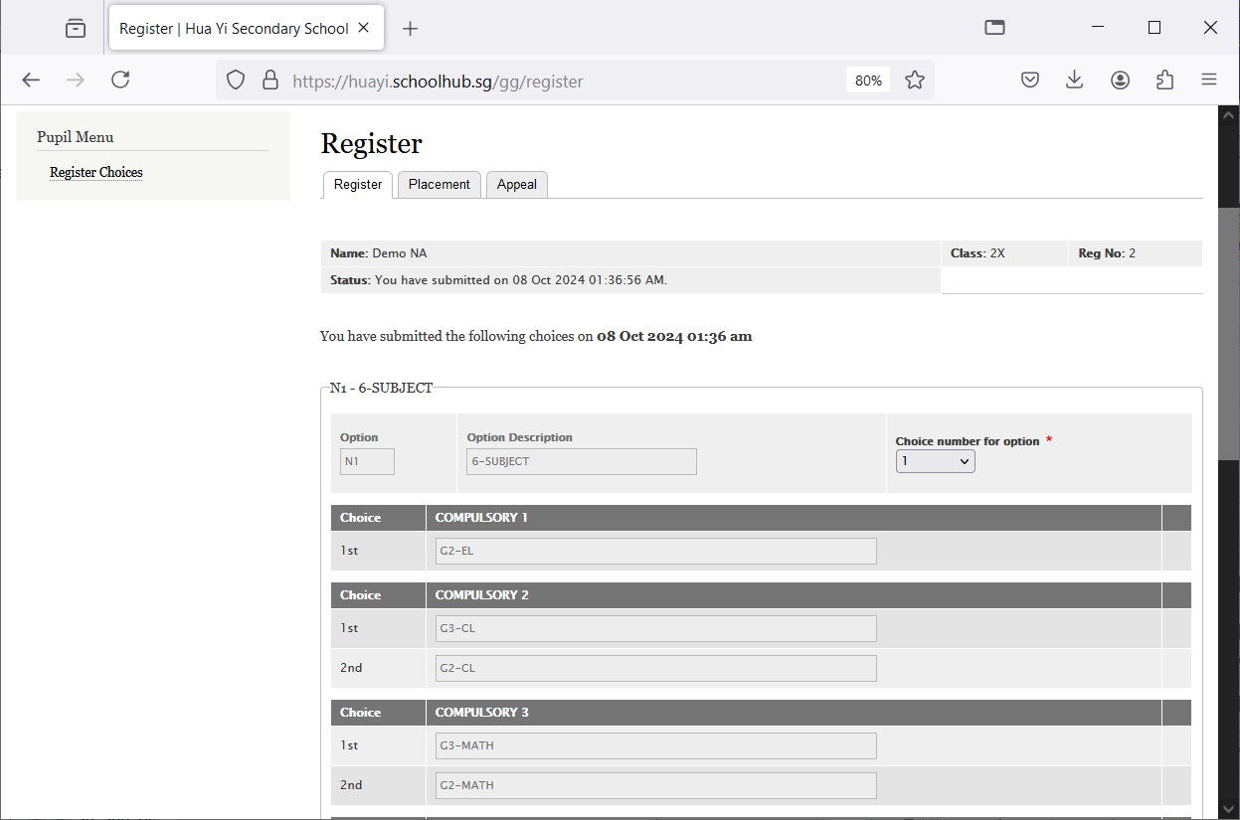

Hold the rectangle box and Drag

If you prefer to take the subject at a Less Demanding Level (LDL), you can drag and drop the choices.

If you are offer the subject at a More Demanding Level (MDL), you will see 2 choices. Default is MDL.

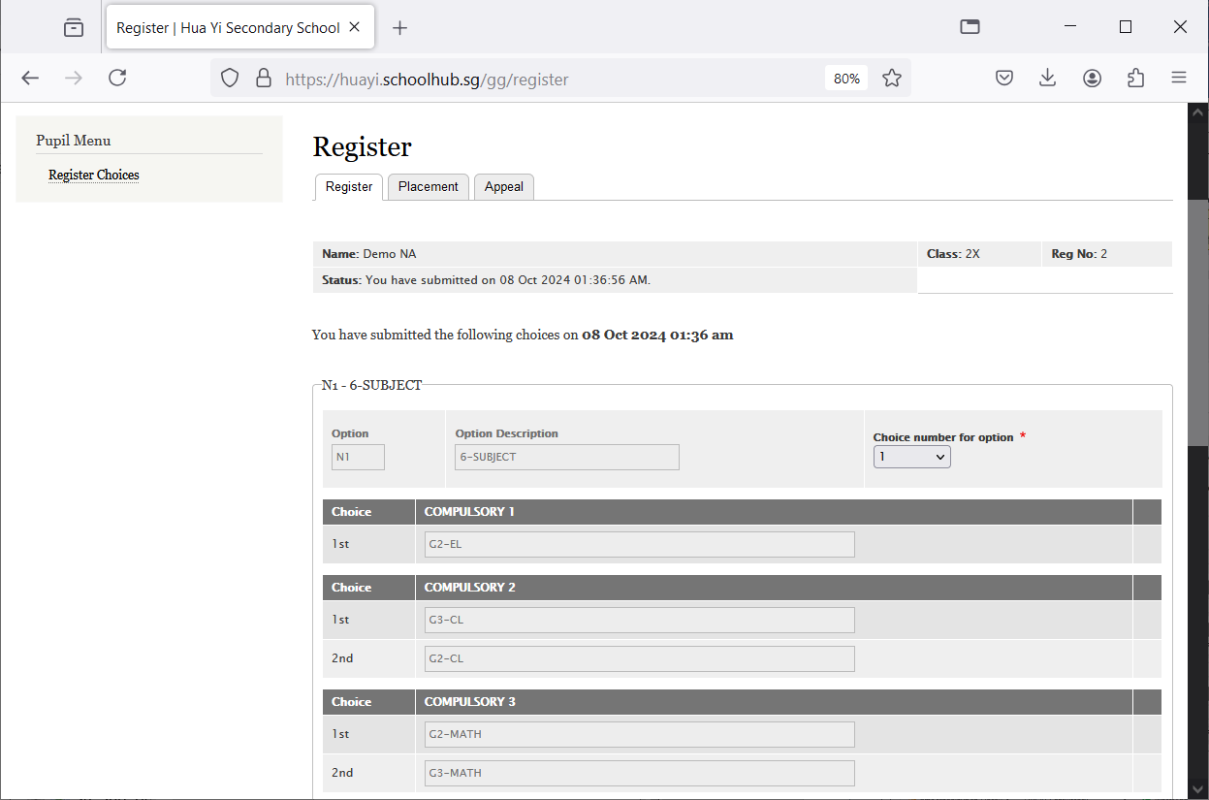

**You prefer to offer G2-MATH.**  
G2-MATH is 1st  
G3-MATH is 2nd

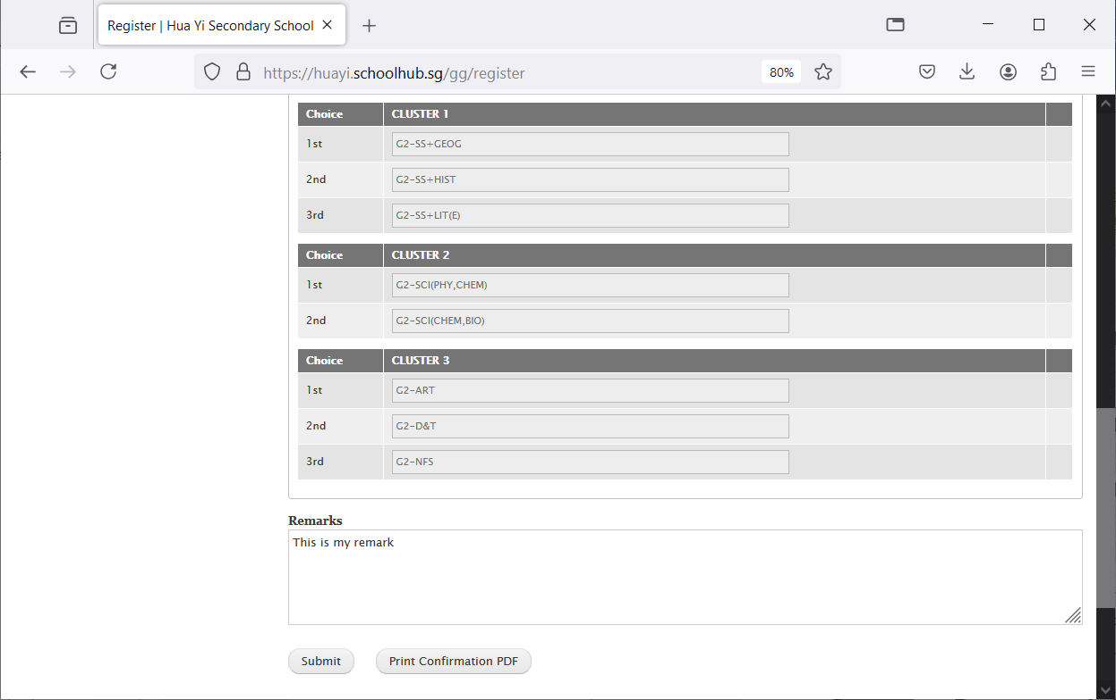

Enter any remark you wish to communicate with your teacher

Click Submit to save your choices. You may change them before the closing date.

Click Print Confirmation PDF to get a copy of the PDF for your reference.

## Sample Result Slip

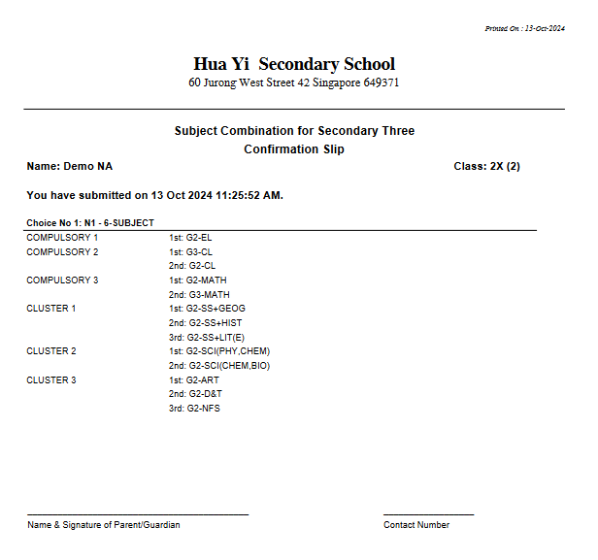

## Check Placement

Select “Placement” Tab

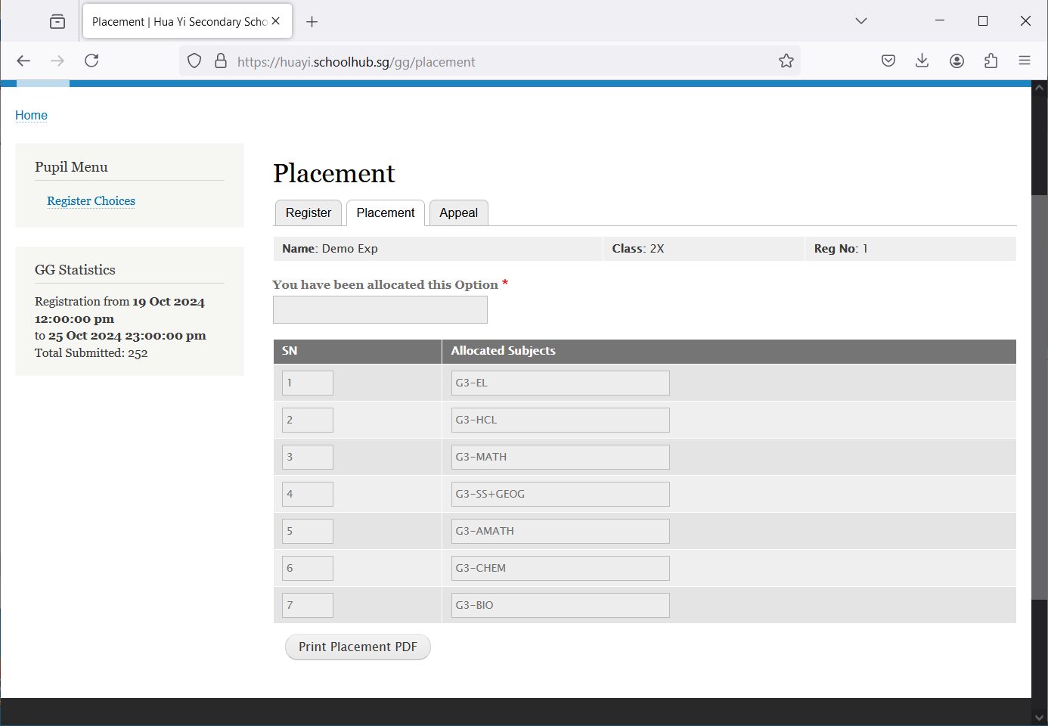

These are the Subjects Allocated

## Appeal

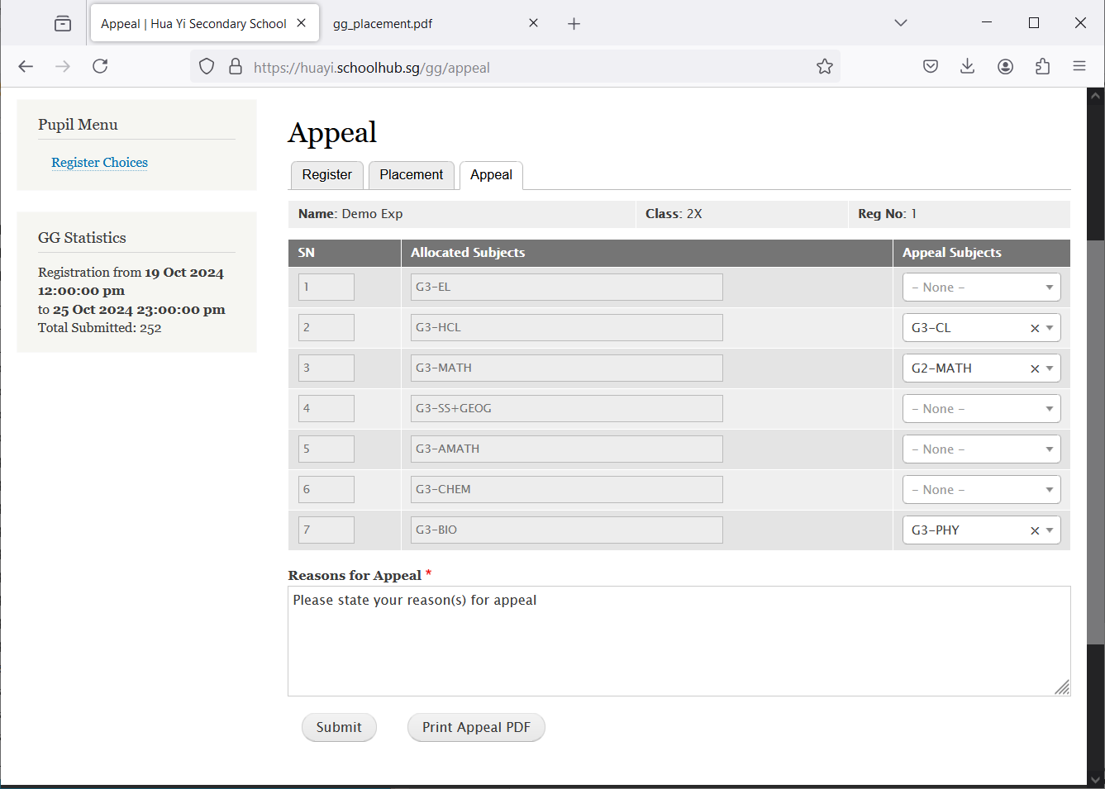

Enter reason(s) or any message you want to communicate with the teacher.

Select Subject to Replace

Click Submit

Click Appeal Slip for your own reference

## Sample Appea Slip

